**Name:- Samreen Shaikh Roll no:- 64**

**Subject:- Big Data Analytics Date:- 25/02/2025**

**PRACTICAL - 16**

**HIVE INSTALLATION**

**STEP I : *Install Hive from the link given below***

***<https://archive.apache.org/dist/hive/hive-2.1.0/>***



**STEP II: *Install Derby from the link given below***

**<https://archive.apache.org/dist/db/derby/db-derby-10.12.1.1/>**



**STEP III: *Unzip Hive and Derby files in C drive.***

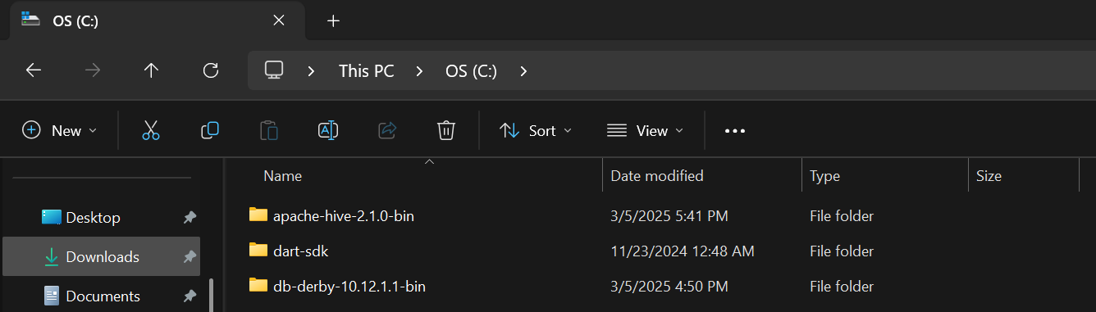

**STEP IV: *Copy all the files from ‘C:\db-derby-10.12.1.1-bin\lib’ to ‘C:\apache-hive-2.1.0-src\lib’ folder.***

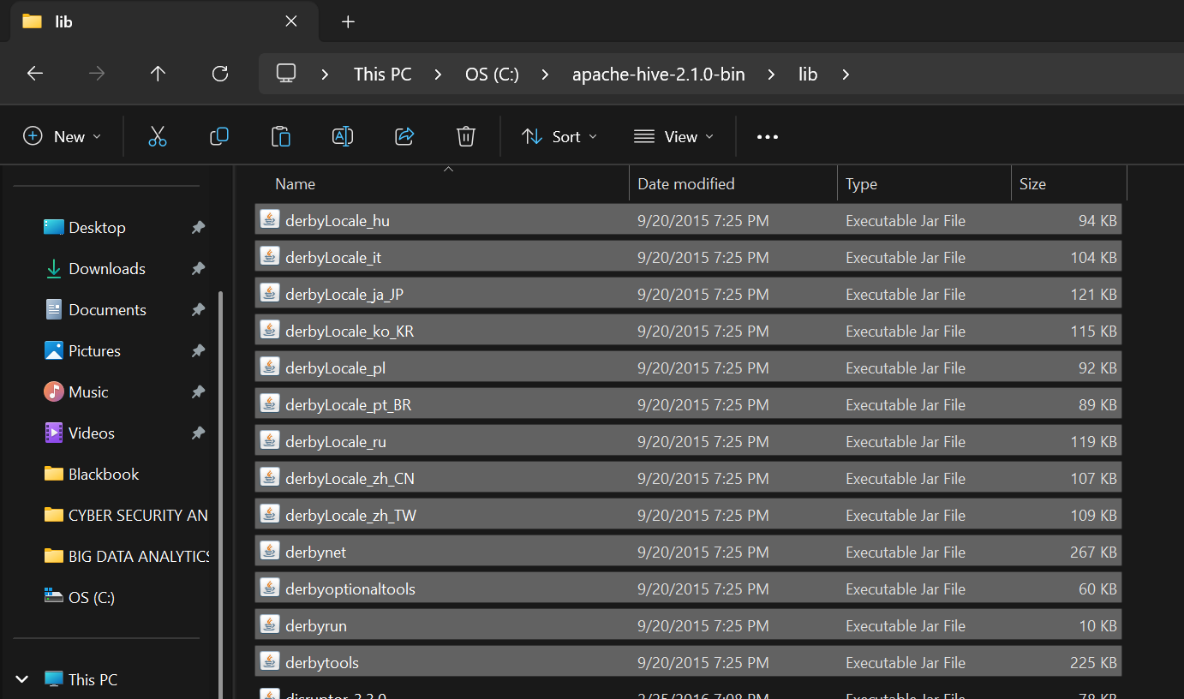

**STEP V: *Set environment variables in into the system variables, user variables and path as shown below.***

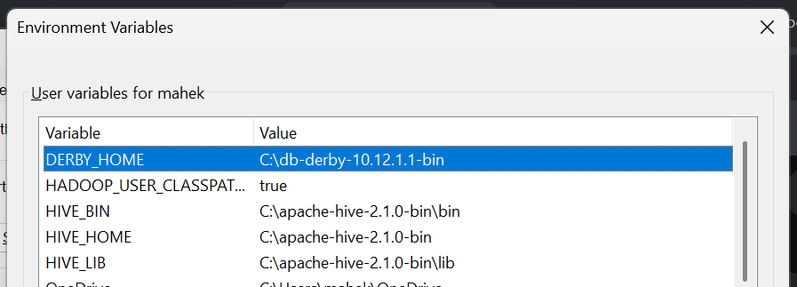

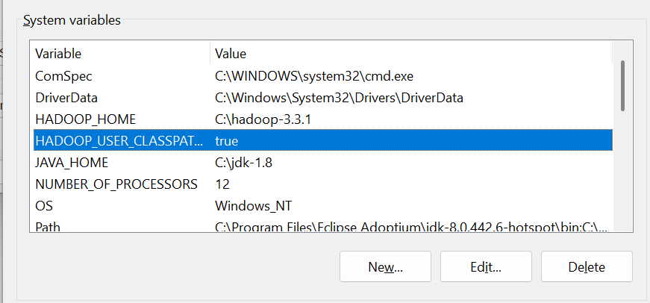



**STEP VI: *Copy hive-site.xml file into hive/conf folder.***

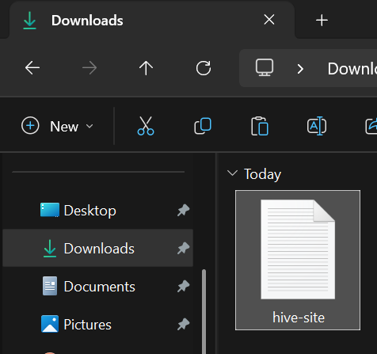

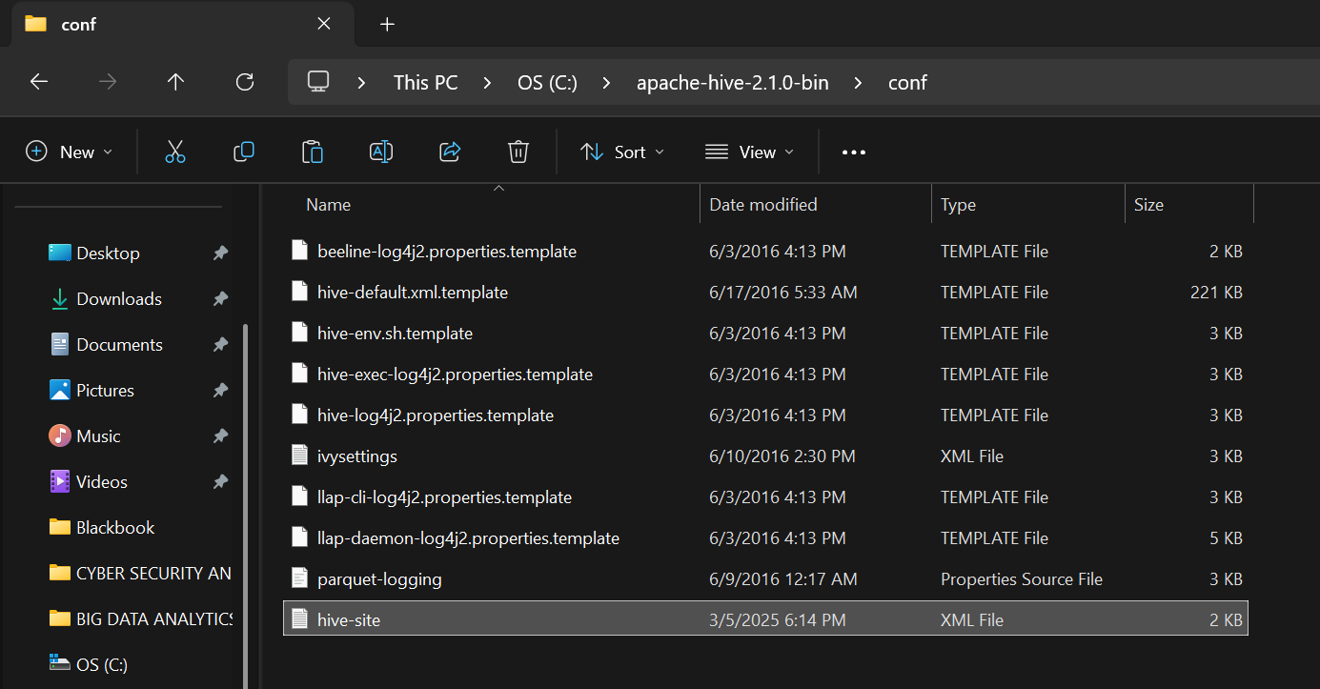

**STEP VII: *Start Hadoop and hive to start working with hive.***

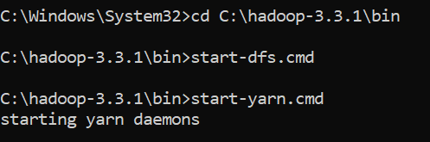



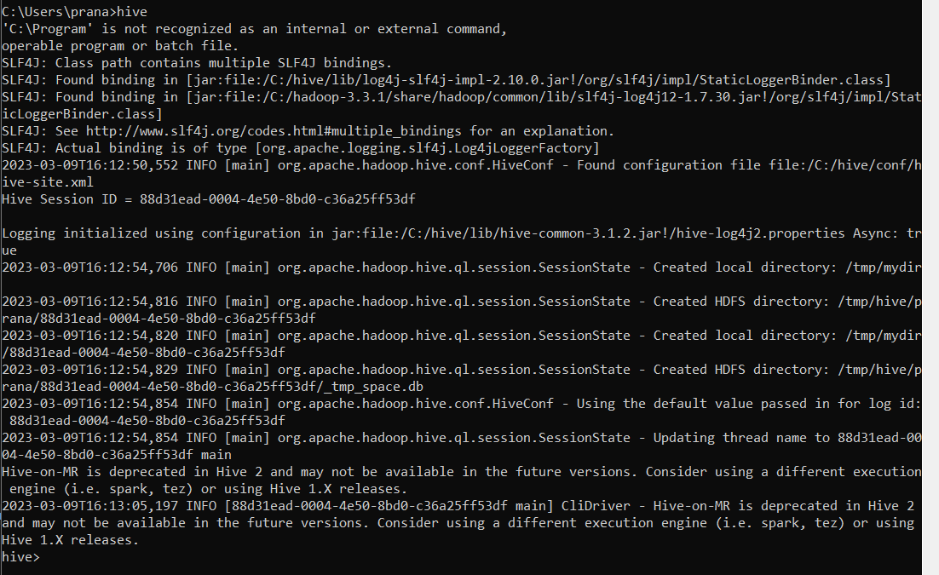

**Hive commands**

1. **Show databases**
2. **Create databases**